University Dashboard Report

A.Project Difinition:

This dashboard provides various data departments and their respective student populations to support making decision.

User:

Zewail University Manager

Required Questions for the Dashboard:

What is the distribution of students across different departments?

Which department has the highest/lowest enrollment?
Which department has the highest/lowest Student’s GPA?

Charts:

Left Pie Chart:

Details:

Pie chart with multiple colors representing different departments.
Labels indicating department names and percentages to make chart more clear.

Questions Answered:

What percentage of total students are enrolled in each department?
Visibility:

Always shows up as an overview.

Chart Type Justification:

Pie charts effectively visualize proportional data and make it easy to see each department’s share of total enrollment at a glance and it one of the best charts that can show percentages from total.

Right Pie Chart:

Details:

A simpler pie chart with three segments, labeled with percentages.

Questions Answered:

What is the distribution among these three specific categories?

Visibility:

Always visible for quick comparison between these categories.

Chart Type Justification:

To provide a overview on these particular department without other data .

Bar Graph Below:

Details:

Bar graph with three bars representing Computer Science, Engineering, and Business.

Questions Answered:

How do student numbers compare between Computer Science, Engineering, and Business?

Visibility:

Always visible for immediate comparison between these major departments.
Chart Type Justification:

Bar graphs offer clear visual comparisons between distinct categories.

Bar Graph Most Below:

Details:

Bar graph with three bars representing estimate of english{Very Good, Good, Bad}.

Questions Answered:

How do student numbers Have a Excellent English?

Visibility:

Always visible for immediate comparison between these English degree.

Chart Type Justification:

Bar graphs offer clear visual comparisons between distinct degree.

C. Dashboard Layout Explanation

Positioning of Charts.

Left Pie Chart:

Positioned at the top left for immediate visibility and to serve as an overview.

Right Pie Chart:

Positioned at the top right for a quick comparison between specific categories.

Bar Graph Below:

Placed below to allow users to delve deeper into detailed comparisons after the initial overview.

Bar Graph Most Below:

This is not most important chart when the user make initial overview.

Justification for Layout:
The layout is designed to provide an immediate overview (pie charts) followed by more specific comparative data (bar graph).
Ensures ease of understanding and accessibility

.Criticisms and Potential Improvements:
The bar graph could include more departments for a broader comparison.
Developed it to be in university website and allow students to shows what achievements of student in other charts

Snapshot of full Dashboard:

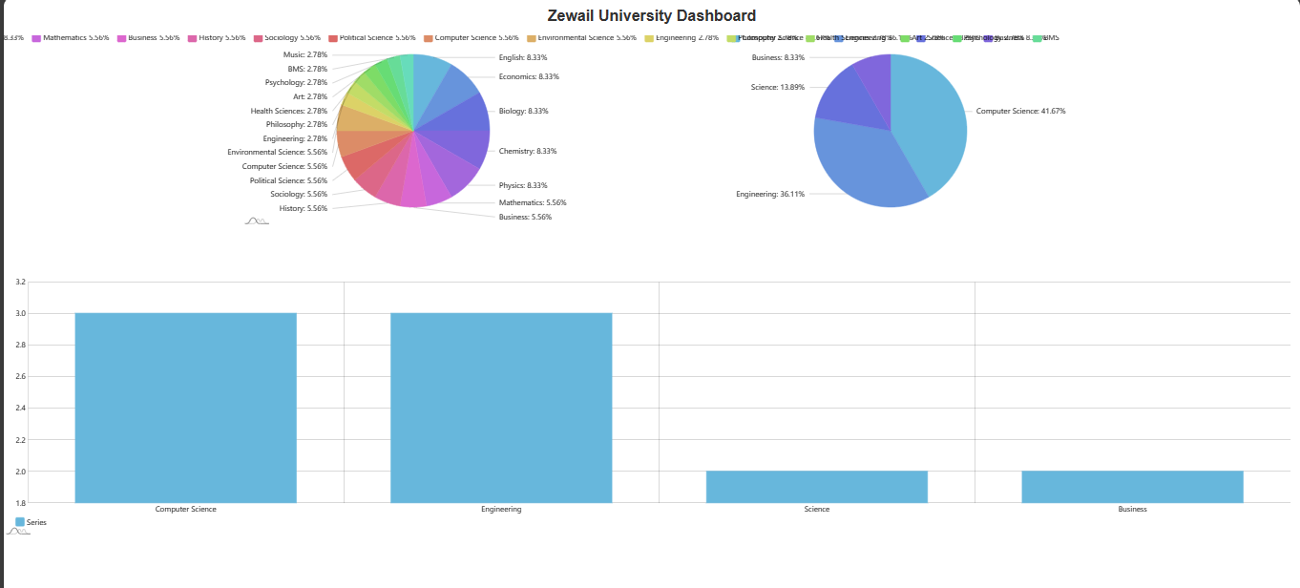
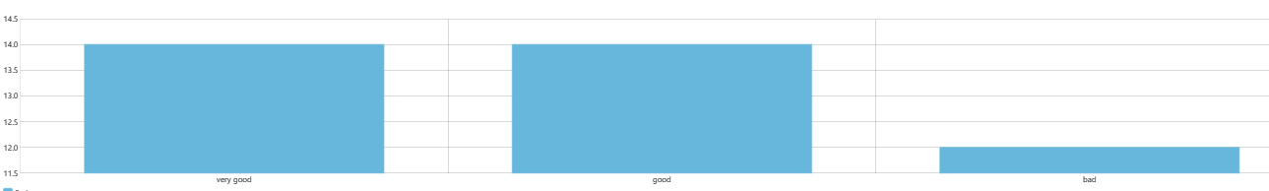

Snapshot of charts individual:

1)
2)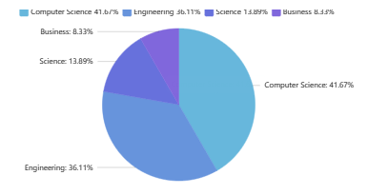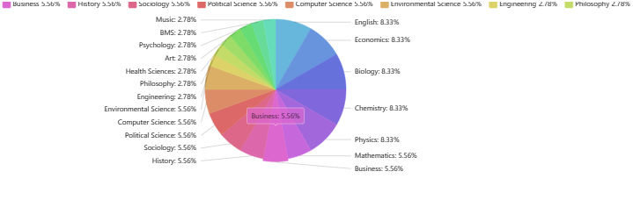
3)
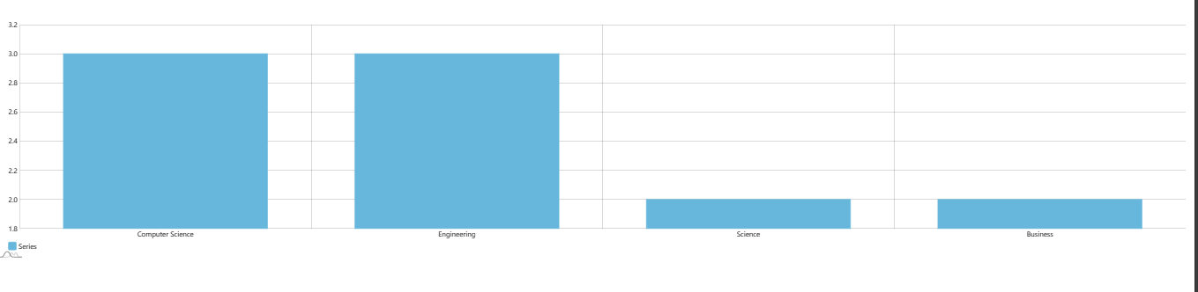

4)

5)dataTable:
